 | The CAMECA IMS 7f and 4f-E7 Software user’s guide  Chained Analyses  00 45 610 693 - Type 108 – Indice A
0000.doc
Index

Contents

1. Introduction 1
2. The Chain Analyses starting dialog box 2
2.1 Available buttons 3
2.2 Available functions 4
3. Definition of a new chained analyses sequence 6
3.1 First steps 6
3.2 Main recipe editor buttons 7
3.3 Shuttle recipe panel 9
3.4 Information associated to a given sample recipe 11
3.4.1 Analysis points list 12
3.4.2 Name and File fields 12
3.4.3 Point buttons 13
3.4.4 Tabs 13
3.5 Defining the analyses positions 19
3.5.1 Importing the point coordinates from the Navigator program (advised) 19
3.5.2 Defining manually the analyses positions 23
3.6 Defining the analysis recipe 24
3.7 Defining the data folder, data filename & format 24
4. Starting the chain analysis sequence 24
5. Logbook file 25

Contents ↑

Introduction

This program allows the operator to run several analyses onto different spots in a batch mode.

This set of analyses can consist of different analysis types (for instance depth profile and mass spectrum can be combined in the same batch) provided that they do not require different ISF files, that is, different Main Analytical Parameters (MAP). The MAP list consist on:
- Nature of primary ions (Cs⁺/O₂⁺/O⁻)
- Primary accelerating voltage (Source HV, e.g. 10kV)
- Impact energy (e.g. 15keV)
- Secondary ion polarity (+/-)
- Secondary ion extraction voltage (Sample HV, e.g. –5kV)

However, a different set of Optional Instrument Parameters (OIP) can be stored for each analysis. For instance, a different primary beam current preset can be defined for each analysis. The OIP set to be used during the acquisition is defined in the analysis definition Window (see the Analysis Software Users Guide). The OIP parameters are the following:
- Raster value (Raster)
- Primary beam preset (Beam)
- Immersion and transfer lenses setting (Max Area)
- Contrast aperture (CA) *
- Field aperture (FA) *
- Entrance slit (Ent) *
- Exit slit (Exit) *
- Energy slit (Ener) *
- DTOS status On or Off (DTOS)
- Electronic gate size (Egate)

* Note: These parameters can be modified during the batch analyses only on instruments equipped with motorized apertures and slits.

The Chain analysis program interface consists on one main dialog box which is used for the chain analysis definition. It is shown in the next Figure. After the chained analyses sequence is started, a second dialog box automatically opens showing the status of the chained analyses. This window also allows a certain number of operations such as stopping or pausing the chained analyses (see §Starting the chain analyses sequence).

A chained analyses sequence defined by the operator must always be saved in a file before starting the chained analyses. The file extension .chm will be automatically added. These files are saved by default in the directory /data/chain.

Contents ↑

The Chain Analyses starting dialog box

Once the Chain analysis program is opened, a dialog box appears as it is shown in the figure below:

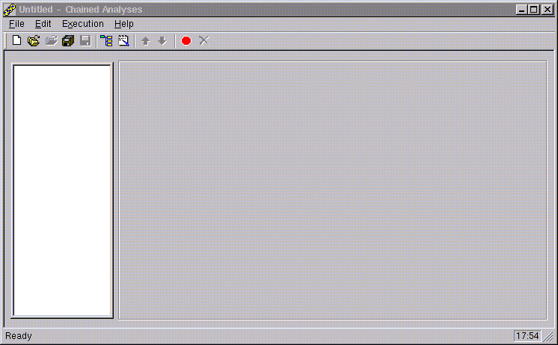

Dialog box header:

The header is used to display the file name of the chained analyses definition file under edition. Note that the labels Untitled or NewRcp displayed in the header means that the analyses sequence under edition has not yet been saved in a file.
Contents ↑

Available buttons

New file ( )

Command to define a new chained analyses sequence. A default file name is automatically generated: NewRcp. A click on New File button provides an empty chain definition dialog box. The Save as dialog box automatically opens if the current chained analyses file has not yet been saved allowing the operator to save it before opening a new file.

Open ( )

This function is used to open a chained analyses definition file (.chm file type).
There is a confirmation prompt if the current chained analyses file has not yet been saved.
A click on Open button opens a file handling dialog box. The operator can navigate through the directories by clicking on the directories name, or go up a level using the usual windows-like features. The list is automatically filtered to select only chained analyses files with extension .chm. A file is loaded by either a double click on its name or a click on the Open button after the file name has been selected with a single click.

( )
Not used.

Save ( )

It saves the present sequence definition in a new file. There is no confirmation prompt before overwriting, except if the file has never been saved and has still the default names Untitled or NewRcp. In this case, the operator must enter a file name: if a file already exists with the same name there is a confirmation prompt before overwriting. After saving, and until the sequence is modified again by the operator, this button remains grayed and is not available.

( )
Not used.

Edit main recipe ( )

It allows the definition of a new chained analyses sequence, the dialog box toggles into the definition mode. The Main recipe editor buttons then appear on the left of the window (see section §Main recipe editor buttons for the definition of a new analysis recipe).

Open Logbook file ( )

This function is used to load a Logbook file (.chm_lb file type). The Logbook files keep all information on the chained analysis sequences. It is mostly used in case of troubleshooting whenever the chained analyses sequence does not finish correctly.
For more information on the Logbook files, refer to section §Logbook file.

Move Up/Down ( )

These buttons allow to change the order of a given sample or point analysis in the chained analyses sequence. They are available only in the definition mode when one of the samples or points to be analyzed are selected.

Start ( )

It starts the chained analyses sequence. Before starting, the program checks that the file names do not already exist in the selected folder. If some of them already exist, the operator is prompted either to allow overwrite or to cancel the Start procedure.

Stop ( )

It stops the analysis sequence. The current analysis is stopped at the end of its current elementary acquisition cycle and data are saved in the raw data file. A chained analyses sequence can be stopped at any time. This button becomes active only after an analyses sequence has been started.
Contents ↑

Available functions

Three main menus are available from the chained analysis dialog box:

File menu

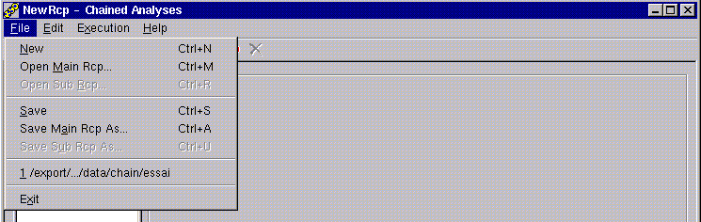

The following functions are available from the File menu:

- New: same as New file button,
- Open main recipe: same as Open button,
- Save: same as Save button,
- Save main recipe as: it saves the present sequence definition in a new file. The operator must enter a file name. If a file already exists with the same name there is a confirmation prompt before overwriting.
- List of the last opened chained analyses files.
- Exit: quits the Chain analysis program. Same as a click on the button on the top right corner of the dialog box.

Edit menu

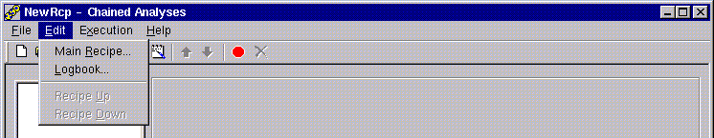

The following functions are available from the Edit menu:

- Main recipe: same as Edit main recipe button,
- Logbook: same as Open Logbook file button,
- Recipe up/down: same as Move Up/Down buttons,

Execution menu

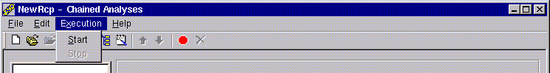

The following functions are available from the Execution menu:

- Start: same as Start button,
- Stop: same as Stop button,
Contents ↑

Definition of a new chained analyses sequence

First steps

1. Open the Chain analysis program by clicking the Chain analysis icon on the IMS 7F/4fE7 main board. The chain analysis definition window opens as shown below.

2. In order to start the definition of a new chained analyses sequence, click on the Edit main recipe button , or select the Main recipe function in the Edit menu. The Main recipe editor buttons then appear on the left side of the window.

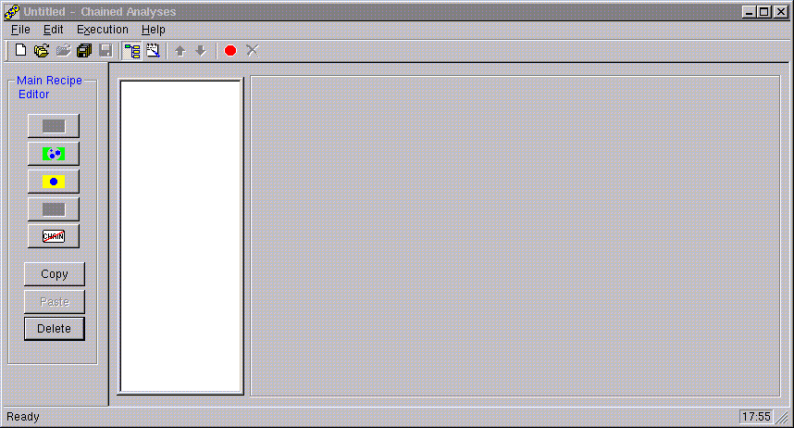

3. Click on the Shuttle recipe button in order to create a new sample-holder definition. The definition window then appears as below:

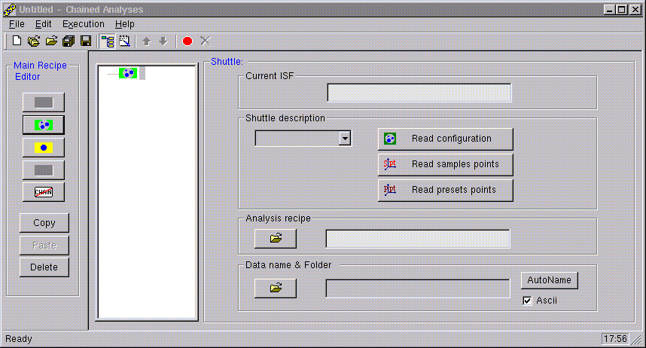

4. At this point, the operator must define the coordinates X, Y of analysis points. There are two ways of defining these points: manual mode (see section §Defining manually the analyses positions), or by importing the points positions already stored in the Navigator program (see section §Importing the point coordinates from the Navigator).

After the coordinates of the analysis points are defined, the operator must then define the remaining chained analyses sequence parameters, such as the analysis recipe file or the raw data filename (see sections §Defining the analyses recipe and §Defining the data folder, data filename & format).

Contents ↑

Main recipe editor buttons

The chained analyses sequence is edited using the Main recipe editor buttons.

If not yet done, click on Edit main recipe button to toggle to the edition mode. In this mode, the Main recipe editor buttons appear on the left side of the dialog box. Next to it, the chained analyses sequence list is displayed.

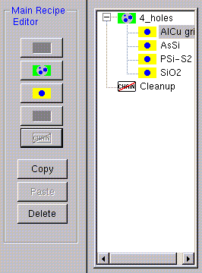
shuttle recipe
sample recipe
Chained analyses
sequence list

Add shuttle recipe
It allows to create a new chained analyses sequence, by adding a shuttle recipe definition. It is the starting point of any chained analyses definition.

Add sample recipe
It adds a new sample recipe to the chained analyses sequence. A sample recipe usually corresponds to a given sample in the sample-holder, and it can then contain one or several analysis points to be defined by the operator. The new sample recipe will be added in the sequence after the sample recipe which is currently selected in the sequence list.

This button is used only when the analyses positions are defined manually. Whenever the analyses coordinates are imported from the Navigator program, the sample recipes are created automatically.

Add cleanup
It adds a stop sources option at the end of the batch sequence. This allows to automatically stop sources (Cs⁺, duoplasmatron, NEG) as soon as the last analysis of the sequence is completed.

Copy
It allows to copy a sample recipe from the chained analyses sequence list to the clipboard. The sample recipe to be copied must be previously selected by a single click on corresponding line in the sequence list.

Paste
It inserts in the chained analyses sequence a copy of the sample recipe previously copied to the clipboard. This sample recipe copy will be inserted in the sequence after the sample recipe which is currently selected in the sequence list.

Delete
It deletes a sample recipe from the analysis sequence. The sample recipe to be deleted must be previously selected by a single click on the sequence list before using the Delete button. This button can also be used to delete the whole chained analysis sequence if the shuttle recipe is selected for deletion.

Also:

The rank of the selected sample recipe within the sequence list can be modified using the Move Up / Down buttons available in the Toolbar on the top of the Chain analysis dialog box.
Contents ↑

Shuttle recipe panel

By selecting the shuttle recipe in the sequence list, the following panel becomes available on the right side of the Chain analysis dialog box:

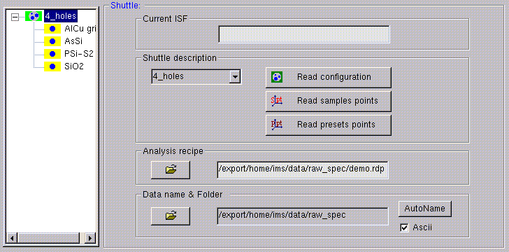

This panel is used to:
- import automatically the analysis points positions from the Navigator program,
- to define the analysis recipe file,
- to select the folder in which the raw data should be saved,
- to automatically define the names of the raw data files,
- to select if Ascii files should or not be saved.

These options will be applied to all analysis points defined in the batch sequence. Afterwards, they can always be modified individually for each analysis point (see section §Tabs).

Current ISF
This field is not available.

Shuttle description
The scrolling menu and buttons associated to this area are used to define the coordinates X, Y of the analysis points by importing the positions stored in the Navigator program (see section §Importing the point coordinates from the Navigator).
- Shuttle description scrolling menu: it is used to select the holder name currently used in the Navigator program, among all existing holder definitions.
- Read configuration button: it imports the sample configuration which has been defined in the Navigator program: a sample recipe will be created for each sample defined in the Navigator program. With this button, only the sample names are imported from the Navigator.
- Read sample points button: it imports the sample names from the Navigator program, and also the sample points coordinates which have been defined for each sample.
- Read preset points button: it imports the samples names from the Navigator program, and also the preset points coordinates which have been defined for each sample.

Analysis recipe

Clicking the button allows to browse the directories of the disk in order to select the analysis recipe (defined previously in the Analysis program) to be applied to the chained sequence. The file name and path are shown in the display field next to this button.

The selected analysis recipe will be applied to all analysis points defined in the batch sequence. However, this selection can then be modified for each individual analysis point (see §Tabs). This is needed in case different analysis recipe files are used during the sequence.

Data name & folder

Clicking the button allows to browse the directories of the disk in order to select the folder in which the raw data files will be saved. The directory name and path are shown in the display field next to this button.

The selected folder definition will be applied to all analysis points defined in the batch sequence. However, this selection can then be modified for each individual analysis point (see §Tabs). This is needed in case the raw data files should be saved in different directories.

Autoname
The Autoname button enters automatically a raw data file name for all analysis points defined in the chained analysis sequence. The file name extension is automatically added according to the analysis type selected.
The file name is built automatically from 1) the File field (same as sample name, when the sample configuration is imported from Navigator), 2) the present date in ddmmyy format, and 3) an automatic label @#, where # is the rank of the analysis within the chained analyses sequence.
The Autoname function will be applied to all analysis points defined in the chained sequence. However, the file name can then be modified for each individual analysis point, by editing it using the keyboard in the individual Filename editing field (see §Tabs).

Ascii
The Ascii check box allows to select or unselected the Ascii option for all analysis points defined in the chained analysis sequence. If this option is selected, an Ascii file will be saved for each recorded raw data file.
If this option is selected in this panel, it will be applied to all analysis points defined in the chained sequence. The status of this option can then be modified individually for each analysis point (see §Tabs).
Contents ↑

Information associated to a given sample recipe

For each sample recipe, one or several analyses can be defined. By selecting a given sample recipe , added manually or by importing the sample configuration from the Navigator program, the following panel becomes available of the right side of the Chained analyses dialog box:

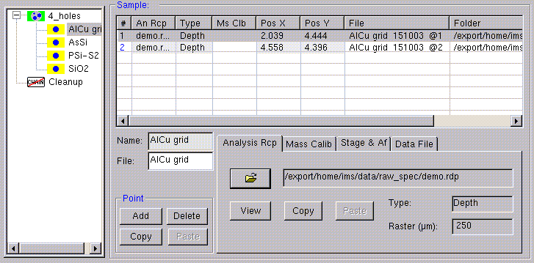
This panel shows all information about the analysis points to be performed for the selected sample (above, as example, the analysis points for AlCu grid sample). In order to have access to the analysis points for a different sample, the corresponding analysis recipe must be selected.
Contents ↑

Analysis points list

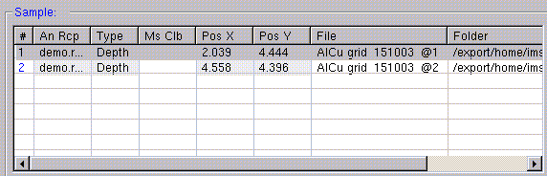
It is located on the top of the dialog box. It displays all information about the analysis points defined for a given sample. In this table, all fields all non-editable.
The operator can have access to all columns or lines by using the scrolling bars. Each line corresponds to a different analysis. The analysis point to be edited can be selected by a simple click on the corresponding line. The analysis list contains several columns:

#: serial number of the analysis. The rank of the selected analysis can be modified within the sequence by using the Move Up / Down buttons .

An Rcp: displays the analysis recipe file name. This file contains the measurement conditions to be applied to the analysis.

Type: displays the analysis type (depth profile, linescan, bargraph, …) to be performed.

Ms Clb: not available.

Pos X / Pos Y: displays the sample stage coordinates to be set for the analysis.

File: displays the raw data file name to be saved.

Folder: displays the directory in which the raw data file will be saved.

Ascii: displays the status of selection (On/Off) for the Ascii file saving option.

Contents ↑

Name and File fields

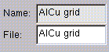

Name
non-editable field. It displays the sample name which has been defined in Navigator program. This field is filled in only when the analysis points have been imported from the Navigator.

File
Editable field. This field will be integrated in the data file name, whenever the Autoname function will be used. By default, this field will be a copy of the Name field.

Both fields will be empty, whenever the sample recipe is defined manually (and not imported from the Navigator program). In this case, it is recommended to enter in the File field a string for sample identification, which will then be used for the data file name when using Autoname function.
Contents ↑

Point buttons
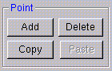

Add
It allows to add one analysis point to the list of points to be measured for the selected sample.

Copy
It allows to copy an analysis point from the list of points to the clipboard. The analysis point to be copied must be previously selected with a single click on the corresponding line in the list.

Paste
It inserts in the analysis points list a copy of the analysis point previously copied. This copy will be inserted in the sequence after the analysis point which is currently selected in the list.

Delete
It deletes an analysis point from the list of points to be measured for the selected sample. The analysis point to be deleted must be previously selected by a single click on the corresponding line in the list.
Contents ↑

Tabs
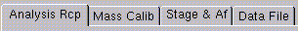

Four tabs are displayed in the lower right side of the dialog box.

These tabs allows to edit the parameters concerning each individual analysis point in the list displayed above. Any parameter edition performed using these tabs will apply only to the selected analysis point in the list. To make the selection of the analysis point, the operator must select the corresponding line in the analysis points list.

Functions associated to each tab are detailed below.

Analysis rcp tab
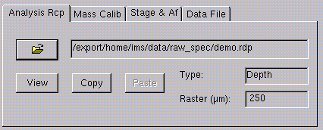

This panel is used to define/modify the analysis recipe file for a given analysis point.

The following buttons are available:

It browses the directories of the disk in order to select the analysis recipe to be applied to the chained sequence. The file name and path are shown in the display field next to this button. The type of analysis recipe and the rater value selected for the analysis are displayed in the Type and Raster fields (display-only).

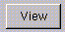
It opens the analysis recipe file in the Analysis program. It is used to check and eventually modify the analysis recipe.

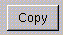
Copy button copies the current analysis recipe filename and path to the clipboard. The analysis recipe filename and path can then be copied to a second analysis point, using the Paste button (the second analysis point must previously selected with a click on the corresponding line in the list).

Mass calib tab

It allows to perform a mass calibration control during the chain analyses. This option can be activated or not for each analysis point of the sequence. By default, this control is not activated. This option can be fully defined only after the analysis recipe was selected for that analysis point.

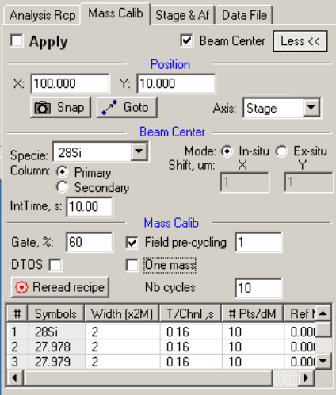
Available buttons/fields:

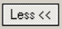
The More/Less button toggles between a expanded/reduced display of the Mass calibration tab.

This check box allows to select or unselect the mass calibration control for the selected analysis point.

This check box allows to select or unselect the beam centering control for the selected analysis point.

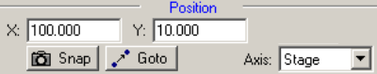

The X and Y fields allow to define the position where the mass calibration control will take place. These values can be edited with the keyboard, or they can be snapped using the Snap button. The operator can also ask to move the stage to the defined position by clicking on the Goto button. The reference axis system is shown in the Axis field.

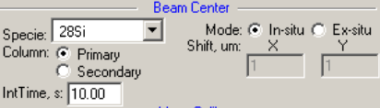

If the Beam centering option has been selected, the operator must define the corresponding parameters:
- Species,
- Primary (Beam Pos deflectors adjustment) or Secondary (DTr or DtFA deflectors adjustment),
- In-situ (performed on same position as the Mass calibration control) or Ex-situ (performed on a position shifted with respect to the position of the Mass calibration control), if Ex-situ is selected the position shift (relative) is defined in the Shift field,
- Integration time (s)

Note 1: This Beam centering control is identical to the one defined in the Analysis program, but it allows to perform this control outside the analysis itself.

Note 2: This Beam centering control is independent of the one defined in the Analysis program. The operator could ask this control in the analysis recipe, and unselect it here, or inversely.

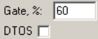
During the Mass calibration control, the operator may define any Gate% value and DTOS status. These values can be different from the ones defined in the analysis recipe it self.

This field allows to define the number of cycles (cycling over the species defined in the analysis recipe) to be performed before the mass calibration.

This check box allows to switch between two types of mass calibration
- if this option is checked: the calibration will be performed on one mass only, but the magnetic fields calibration is corrected for all species accordingly to the variation found for the selected species. In this case, the operator must select the species for the mass scan on a scrolling menu displayed on the right side of this check box which proposes all the species defined in the analysis recipe.
- if this option is not checked: the mass calibration will be performed for all species, the magnetic field calibration being corrected for each species independently.

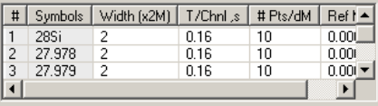
The list on the bottom allows to modify the mass calibration parameters (scanned ranged, number of points, integration time /point)

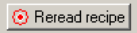
A click on this button allows to refresh the parameters by reading the current analysis recipe. It is useful if the analysis recipe is modified.

Stage & af tab
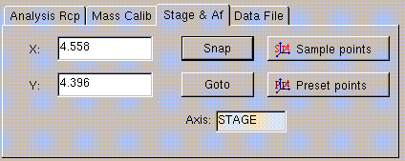

This panel is used to define/modify the coordinates for a given analysis point.

X & Y fields
They display the current coordinates for the selected analysis point (in mm units). The reference axis for which these coordinates are defined is displayed in the Axis field (read-only).

These values can be edited using the keyboard. Press Return pad key to validate the entered values.

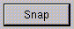
It allows to snap the current sample stage position. The X & Y coordinates will be automatically updated.

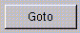
It allows to move the sample stage position to the coordinates displayed in the X & Y fields.

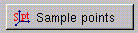
It allows to import the sample name and sample points coordinates which have been defined for the selected sample only.

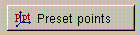
It allows to import the sample name and preset points coordinates which have been defined for the selected sample only.

Data file tab
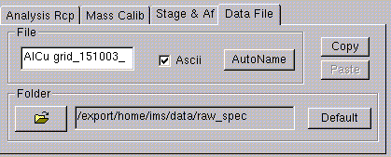

This panel is used to define/modify for a given analysis point:
- the folder in which the raw data should be saved,
- raw data file name,
- Ascii file saving status.

File field
It displays the raw data file name for the selected analysis point. This field can be edited using the keyboard. Press Return pad key to validate the entered string.

This check box allows to select or unselected the Ascii option for the selected analysis point. If this option is selected, an Ascii raw data file will also be saved for that analysis.

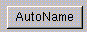
The Autoname button enters automatically a raw data file name for all the analysis points in the list. However, it does not apply to different sample recipes. The file name extension is automatically added according to the analysis type selected.
The file name is built automatically from 1) the File field (same as sample name, when the sample configuration is imported from Navigator), 2) the present date in ddmmyy format, and 3) an automatic label @#, where # is the rank of the analysis within the chained analyses sequence.

It allows to browse the directories of the disk in order to select or modify the folder in which the raw data file for the selected analysis point will be saved. The directory name and path are shown in the display field next to this button.

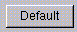
This button allows to reset, for the selected analysis point, the folder path (for raw data file saving) to the one defined in the main panel for the whole chain analysis (see §Shuttle recipe panel).

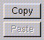
Copy button copies the current folder path (for raw data file saving) to the clipboard. This path can then be copied to a second analysis point, using the Paste button (the second analysis point must previously be selected with a click on the corresponding line in the list).

Contents ↑

Defining the analyses positions

Before starting the analysis points coordinates, the operator must previously follow the first steps procedure described in section §First steps. It is then time to define the coordinates of the points to be analyzed, either manually or by importing the positions stored in the Navigator program.
Contents ↑

Importing the point coordinates from the Navigator program (advised)

In this case, the sample configuration and positions are imported from the Navigator program.

a) In Navigator program:

The functions of the Navigator program needed for the analysis positions definition will be given here. For a more detailed description of this program, see Software_users_guide-Navigator_7f.

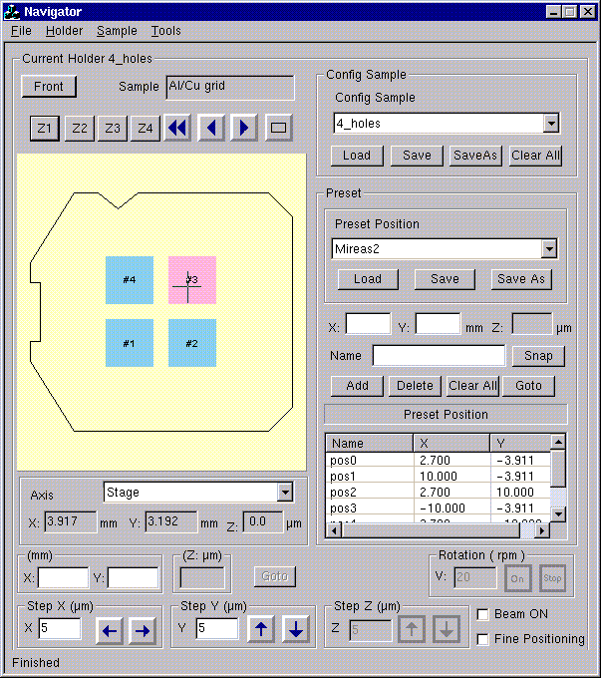

First of all, it is necessary to define the sample configuration for the present holder.

Procedure to define a sample configuration

The operator must previously select the holder configuration corresponding to one in the analysis chamber (using the Load function in the Holder menu of the Navigator window).

A sample ID must then be defined for every sample loaded in the sample-holder, or at least for every sample that will be analyzed in chained mode. To do this:

1. Click right mouse button on the target window in the synoptic,
2. Select Edit sample in the displayed menu,
3. Fill the different editing fields (all optional except Sample name),
4. Click OK to validate the edition.

When a sample name is defined for a window (Sample_ID edited) the color turns from light grey into light blue. When a window becomes the present window, it turns into light red color.

A sample configuration is associated with a sample configuration file, the file name being displayed in the Config sample field (see below). This file can be saved using the Save as or Save buttons available below this field.

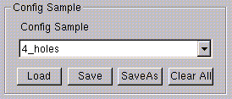

Whenever the sample configuration is imported into the Chain analysis program, the sample configuration file is automatically saved. If a file name has not yet been defined for the file, a dialog box will open asking the operator to enter a name for the file.

Procedure to define Preset positions

The most usual procedure consists on importing in the Chain analysis program, not only the sample configuration but also the preset points coordinates defined using the Navigator program.
Important: The sample configuration (as described previously) must be defined before selecting the preset positions.
The figure below shows the Navigator window section dedicated to the handling of the preset positions. The list of preset points is shown at the bottom. A preset point is defined by the three coordinates X, Y and a name which is used for its identification.

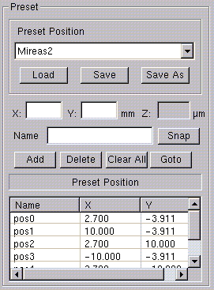

To define a new preset point:

1. Click on Snap button to copy in the X, Y editing fields the current position of the sample stage. The X, Y positions can also be edited manually.
2. Edit an ID in the name editing field. By default, the ID is given after the sample ID defined for that position in the sample configuration.
3. Click on Add button to add a preset point to the current list. There is a confirmation when adding a preset point with an ID already existing in the list.

A list of preset positions is associated with a preset positions file, the file name being displayed in the Preset position field (see above). This file can be saved using the Save as or Save buttons available below this field.

Whenever the preset points are imported into the Chain analysis program, the preset points file is automatically saved. If a file name has not yet been defined for this file, a dialog box will open asking the operator to enter a name for the file.

Procedure to define Sample positions

Other than the preset points, the operator can also define sample points. The sample positions are mainly oriented to the definition of a sample with patterns. The sample points can be imported in the Chained analyses program.
Important: The sample configuration (as described previously) must be defined before selecting the sample positions.
For the sample positions, the coordinates are defined in the Sample axis system. In this axis system, the point (0,0) corresponds to the center of the sample. A list of sample positions can be defined for each sample.
In order to edit the sample positions:
1. Click right mouse button on the target window in the synoptic,
2. Select Edit sample in the displayed menu, The Edit sample ID dialog box opens.
3. Click on Edit point button. The Edit sample type dialog box opens (see figure below).
4. Edit manually the X, Y editing fields the coordinates position in the Sample axis system.
5. Edit an ID in the name editing field.
6. Click on Add button to add the sample point to the current list. There is a confirmation when adding a preset point with an ID already existing in the list.
The figure below shows the Edit sample type dialog box dedicated to the handling of the sample positions. The list of sample points is shown in the middle of the dialog box. A preset point is defined by the coordinates X, Y and a name which is used for its identification.

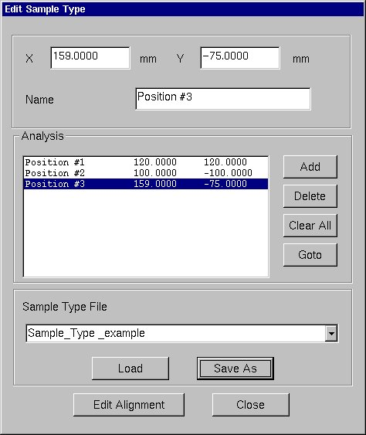

A list of sample positions is associated with a sample positions file, the file name being displayed in the Sample type file field (see above). This file can be saved using the Save as function available.

Whenever the sample points are imported into the Chained analyses program, the sample points file is automatically saved. If a file name has not yet been defined for this file, a dialog box will open asking the operator to enter a name for the file.

b) In Chain Analysis program:

First, the holder name currently used in the Navigator program must be selected using the Shuttle description scrolling menu:
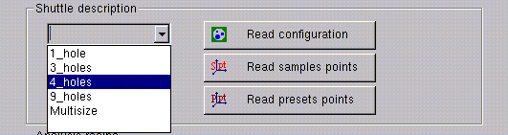
Second, one of the three buttons Read configuration, Read sample points, Read preset points should be pushed in order to import the corresponding information from the navigator window (see also section §Shuttle recipe panel).
- Read configuration imports the sample configuration only,
- Read sample points imports the sample configuration and the sample points coordinates defined for each sample,
- Read preset points imports the sample configuration and the preset points coordinates defined for each sample.
Contents ↑

Defining manually the analyses positions

The manual mode consists on manually inserting sample recipes and, for each sample recipe, the required analysis points.

This mode can be combined with the automatic importation from the Navigator program. After an importation of the analysis points from Navigator, the operator can include additional sample recipes, or for a given sample recipe, additional analysis points. However, each time the stored points in Navigator are imported, all current analysis points will be erased.

Procedure to define analyses positions manually

As example, we will suppose that the operator has two samples (sample1 and sample 2) in the sample holder to analyze, with two analysis points for sample1, and three analysis points for sample2.

In order to edit the sample positions:
1. Follow the first steps detailed in section §First steps,
2. Click on Add sample recipe button two times in order to create two sample recipes (one for each sample) in the chained analyses sequence list.
3. Select the first sample recipe in the analyses sequence list.
4. Edit a sample ID in the File editing field (e.g. sample1).
5. Click on Add button to add an additional sample point to the current list (one analysis point is created by default for each sample recipe).
6. Select the second sample recipe in the analyses sequence list.
7. Edit a sample ID in the File editing field (e.g. sample2).
8. Click on Add button two times to add two additional sample points to the current list (one analysis point is created by default for each sample recipe).
9. In Chain analysis program, select the sample recipe corresponding to sample1, and then the first line corresponding to the first analysis points.
10. Using the Navigator program or the stage thumbwheels, move the sample stage to the position of the first point of sample1 to be analyzed.
10. Select the Stage & Af tab, and click the Snap button to snap the current sample stage coordinates. These coordinates are automatically entered in the X & Y editing fields.
11. Repeat steps 8 to 10 to define the coordinates for the remaining analysis points.

After this procedure, all analysis points coordinates will be entered in the chained sequence.

Note that the stage coordinates must be defined for all analysis points, otherwise, the chain analysis sequence will not start (a warning message is displayed).

Contents ↑

Defining the analysis recipe

After defining the analysis points coordinates, the operator must define the analysis recipe(s) for the analysis points. A common analysis recipe can be defined for all analysis points (see §Shuttle recipe panel), but the analysis recipe can also be individually defined for each analysis point (see §Tabs). The common definition is advised, as it is a quicker operation (the operator can then individually modify it for given analysis points if required).

Note that an analysis recipe must be defined for all analysis points, otherwise, the chain analysis sequence will not start (a warning message is displayed).

Contents ↑

Defining the data folder, data filename & format

The operator must also define the folder in which the acquired data will be saved, the corresponding filenames, and if an Ascii file should also be saved or not. A common definition is possible for all the analysis points (see §Shuttle recipe panel), but these parameters can also be individually defined for each analysis point (see §Tabs). The common definition is advised, as it is a quicker operation (the operator can then individually modify it for given analysis points if required).

Note that these parameters must be defined for all analysis points, otherwise, the chain analysis sequence will not start (a warning message is displayed).

Contents ↑

Starting the chain analysis sequence

Saving the chained sequence definition

Before starting the chain analyses sequence, the chain analysis definition must be saved, otherwise, the chain analysis sequence will not start (a warning message is displayed).

This can be performed by clicking on the Save button , or by selecting the Save or the Save main recipe as functions in the File menu.

For the Save main recipe as function (File menu), a file windows dialog box opens, and the operator must enter a filename. If a file already exists with the same name, there is a confirmation prompt before overwriting.

For the Save button or the Save function (File menu), there is no confirmation prompt before overwriting, except if the file has never been saved and has still the default names Untitled or NewRcp. In this case, the operator must enter a file name: if a file already exists with the same name there is a confirmation prompt before overwriting.

After saving, and until the sequence is modified again by the operator, this button remains grayed and is not available.

Starting the chained analysis sequence

In order to start the chained analyses sequence, click on the Start button , or select the Start function in the Execution menu.

Before starting the sequence, the program checks that the filenames do not already exist in the selected folder. If some of them already exist, the operator is prompted either to allow the overwrite or to cancel the Start procedure.

During the chained analysis sequence

After the chained analyses sequence is started, a second dialog box automatically opens showing the status of the chained analyses. This window also allows a certain number of operations such as stopping or pausing the chained analyses.

Note that one or several analysis point can be skipped during the execution. This can be performed by selecting the corresponding point in the analysis point list and than by clicking on the (…) button, available on the Toolbar. The line corresponding to this analysis point appears then in italic characters.

Contents ↑

Logbook file

The Logbook files (.chm_lb file type) keep all information on the chained analysis sequences. It is mostly used in case of troubleshooting whenever the chained analyses sequence does not finish correctly.

A Logbook file is saved for every chained analyses sequence which are run in the machine. For the same chained analyses definition, a Logbook file will be stored each time the sequence is run. The Logbook file name is composed of the chained analyses file name added with the date on which the sequence has been run plus an automatically generated number.

The Logbook file gives all information about each analysis point.
- Date,
- Recipe file,
- Coordinates used for the mass calibration ClbX, ClbY:
  - if this position could not be reached (for example, due to lack of communication with the stage motors) the coordinates will appear in square brackets [xxx],
  - if no problem was encountered, the coordinates appear in round brackets (xxx),
- Coordinates used for the analysis X, Y:
  - if this position could not be reached (for example, due to lack of communication with the stage motors) the coordinates will appear in square brackets [xxx],
  - if no problem was encountered, the coordinates appear in round brackets (xxx),
- Mass calibration: blank space if the mass calibration option was not selected
  - if the mass calibration could not be performed (for example, due to lack of communication with the Mass calibration program), the message Failed is displayed,
  - if no problem was encountered, the message Ok is displayed. The results of the mass calibration procedure are shown on a list, which can be displayed by clicking on the right side of the corresponding cell,
- Beam centering (available in the mass calibration option): blank space if the beam centering option was not selected
  - if the beam centering control could not be performed (for example, in the absence of counting rate giving a black image), the message Failed is displayed,
  - if no problem was encountered, the message Ok is displayed. The results of the beam centering procedure are shown on a list, which can be displayed by clicking on the right side of the corresponding cell,
- File (File)
  - if the acquisition file could not be saved (for example, due to lack of communication with the Analysis program), the message Failed is displayed,
  - if no problem was encountered, the filename of the data file is displayed,

If a line corresponding to a given analysis point is shown with italic format, it means that this analysis point was skipped during the chain analysis sequence (see §Tabs).

Contents ↑

